***Ron***

* As of right now, the code will consistently output that there is no file even after generation.
  + Wrong file path?
  + File path being deleted immediately?
  + Seems like the code can’t see it because somewhere else has the code being deleted…
    - Generate zip deletes the file before my code can see it.
      * Different deletion occurring

zip_file_path_noExt: \/var\/www\/html\/uas_data\/download\/product\/2022_Corpus_Christi_Cotton\/20220523_cc_p4r_parking_mosaic_2022_cc_corn_boundary\/2022_Corpus_Christi_Cotton_20220523_cc_p4r_parking_mosaic_2022_cc_corn_boundary_results\

zip_file_path: \/var\/www\/html\/uas_data\/download\/product\/2022_Corpus_Christi_Cotton\/20220523_cc_p4r_parking_mosaic_2022_cc_corn_boundary\/2022_Corpus_Christi_Cotton_20220523_cc_p4r_parking_mosaic_2022_cc_corn_boundary_results.zip

* Need to add the period to .zip
  + DONE
* Can you download the data after it tells you you can?
  + Yes and no.
  + GenerateResults still continues after checkZip runs
    - Need to run a T/F case to pass to PHP, then in the JS, skip the activation of generate results to just download the zip.
    - May need to attempt something else to attempt the case value to pass (Rosendo’s pop-up)

Before:

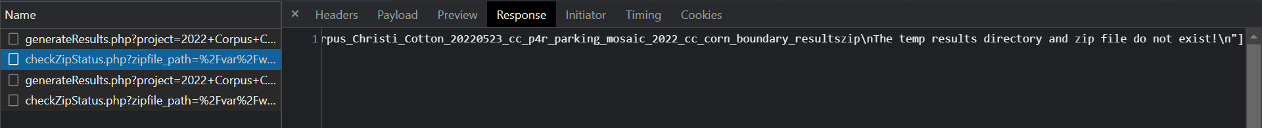

After:

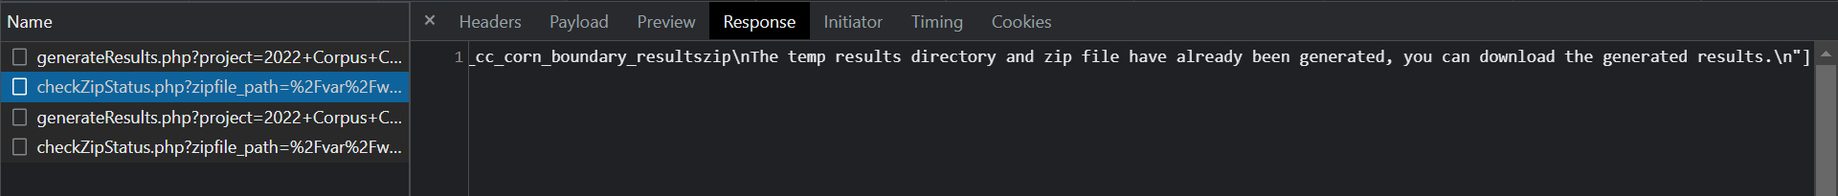

4 hours of work in lab

***Campbell***

* Recently switched focus to another task, changing of the directory architecture instead of completing file merging.
  + File merging will be easier when an exact file path is established for all of the separate zip files.
  + 4 zip files produced, one for each attribute.
  + Merged files may need to be left in the top level of the final zip product.
* Error with the first selected orthomosaic attributes, for some reason the data folder for the first orthomosaic does not appear in the directory tree.
  + DONE
  + There was another variable assignment between the instantiation and jquery call to the PHP file.
* After the directory and generateZip.py are both finished, Ron and I can start integration.
  + This includes making sure we have the same file paths for checking and delivering the Zip file
  + This includes stopping the attribute generation whenever a previously generated zip file is found in the directory.

***Rosendo***

* I emailed the sponsor in order to get access to the new multispectral data so I can update the UI with the different sensors and platforms depending on the attributes needed
* Work I have done since last week would be the implementation of warnings/pop ups depending on the requirements the sponsors have given me. You can see some of the warnings in the images below for reference.

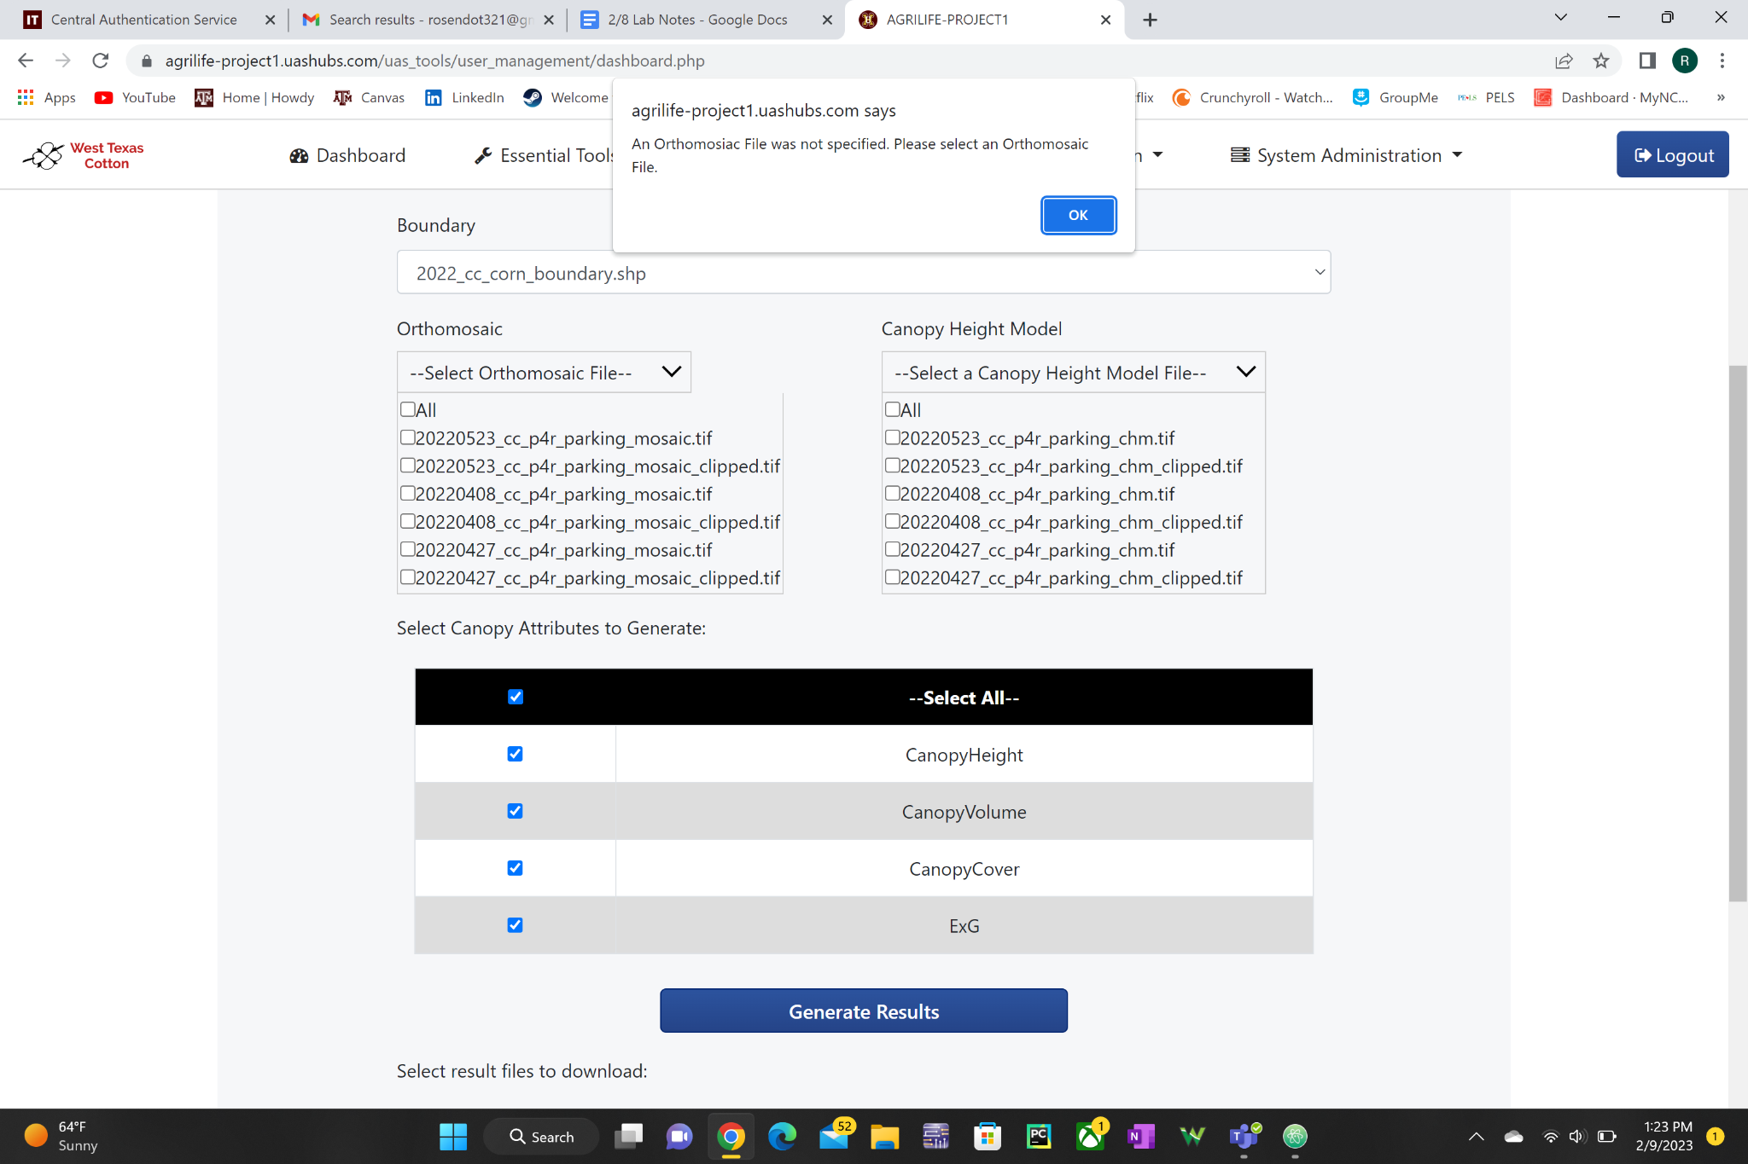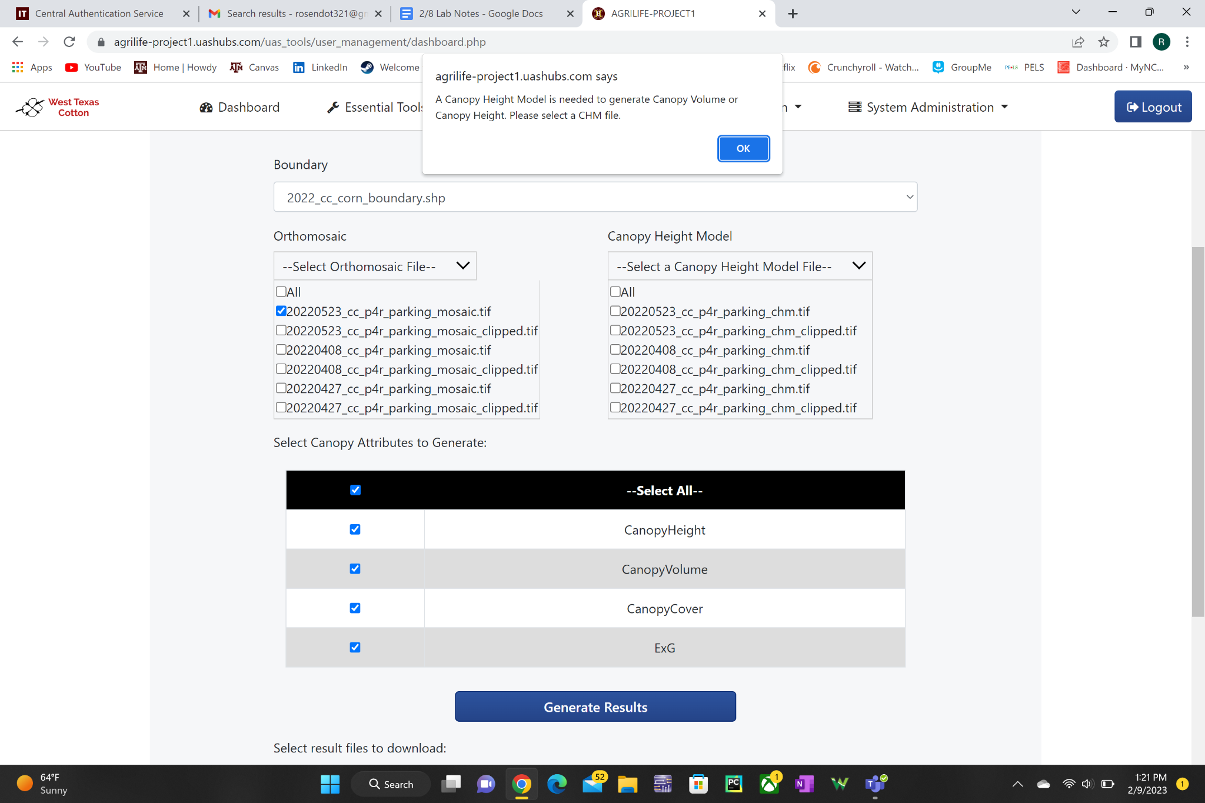

* As far as current work I am working on editing the dropdown menus to only populate based on the newly added boundary files
  + As you can see the Orthomosaic and Canopy Height Model Dropdown menus populate with every single available file instead of categorizing them and populating the specific files available to the boundary file. I will be working on this small issue for the next week and a half until I get access to the multispectral data files

